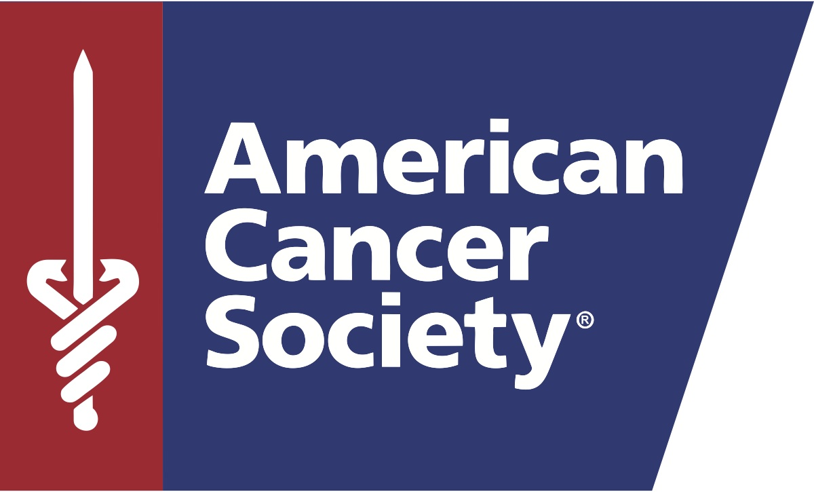
Media Contact:
Jennifer Walker
jennifer.walker@cancer.org
C: 281-782-4646

THE RICHARD M. SCHULZE FAMILY FOUNDATION PLEDGES $10 MILLION
CHALLENGE GRANT TO AMERICAN CANCER SOCIETY HOPE LODGE HOUSTON

Naming Rights of Hope Lodge Granted to Foundation for Large Donation

HOUSTON, October 4, 2016 - The American Cancer Society (the Society) today announced that its campaign to build a Hope Lodge facility in Houston has received a $10 million one-to-one challenge grant from the Richard M. Schulze Family Foundation (RMSFF) to name the building. The Richard M. Schulze Family Foundation American Cancer Society Hope Lodge© facility in Houston will provide 23,000 nights of free lodging each year, and support for cancer patients and their caregivers who must travel far from home to receive treatment in the Greater Houston area.
Best Buy founder Richard “Dick” Schulze created the RMSFF in 2004 as a way to give back to the community. “Every family, including my own, has been affected by cancer,” said Dick Schulze, founder and chairman of the RMSFF. “Battling the disease is challenging enough without the financial and emotional stress of traveling for treatments. The Hope Lodge is a vital addition to the Houston medical community, as it helps patients and caregivers remain focused on getting well, rather than worrying about where to stay and how much it will cost.”
The Richard M. Schulze Family Foundation American Cancer Society Hope Lodge will save cancer patients more than $3 million every year. This Hope Lodge will serve as a patient-centered facility during critical treatment time and as a home away from home for patients visiting treatment facilities in Houston.
The Richard M. Schulze Family Foundation American Cancer Society Hope Lodge will join 32 other Hope Lodge locations currently open across the country. Due to patient demand, Houston’s Hope Lodge facility will be the largest in the nation, with 64 patient suites, a shared kitchen, dining spaces, a help-yourself pantry, daily access to fresh linens, patient laundry facilities and a library with Internet access as well as free transportation to and from treatment facilities. American Cancer Society Hope Lodge facilities provide a caring and nurturing environment, where patients can focus on their own personal recovery without the worry of where to stay and how to pay.
“We are extremely thankful for the Schulze Family Foundation’s generous gift in support of Hope Lodge Houston,” said Gary M. Reedy, American Cancer Society CEO. “Houston continues to be a flagship of hope for so many seeking treatment and a Hope Lodge in Houston will enable thousands more each year to access the superior care offered within this world-class medical community.”
The American Cancer Society secured 2.05 acres of land on Ardmore Street in the Texas Medical Center which will be the future home of Hope Lodge Houston. Groundbreaking is tentatively set for August 2017; the facility will be completed and open to patients by the fall of 2018.
The Society is honored to have President George and Mrs. Barbara Bush as honorary co-chairs, and Robert and Janice McNair as Hope Lodge Houston’s campaign co-chairs. They have afforded us their dedication, enthusiasm and investment. Robert and Janice McNair generously committed $1 million early in the campaign, and then followed with a pledge of an additional $4 million as part of a successful challenge that was met at the end of 2015.
This $10 million Richard M. Schulze Family Foundation challenge grant extends until December 31, 2017, and will mark the conclusion of the Hope Lodge Houston campaign, with only $3 million left to raise to complete the campaign’s ultimate goal of $30 million. Whether a gift of $10 or $100,000, the Richard M. Schulze Family Foundation will increase your contribution. This provides an incredible opportunity for everyone’s gift to make a greater impact and help the Society meet this challenge and reach its campaign goal.
To donate or learn more about the Hope Lodge Houston campaign, please visit our website at www.cancer.org/hopelodgehouston, or you may contact Sandy Biggers, campaign director, at (713) 706-5640 or sandy.biggers@cancer.org. Together, we can Build hope & Touch lives.
###
About the American Cancer Society

The American Cancer Society is a global grassroots force of 2 million volunteers saving lives in every community. As the largest voluntary health organization, the Society's efforts have contributed to a 23 percent decline in cancer death rates in the U.S. since 1991, and a 50 percent drop in smoking rates. We're finding cures as the nation's largest private, not-for-profit investor in cancer research, ensuring people facing cancer have the help they need and continuing the fight for access to quality health care, lifesaving screenings and more. For more information, to get help, or to join the fight, call us anytime, day or night, at (800) 227-2345 or visit cancer.org.

